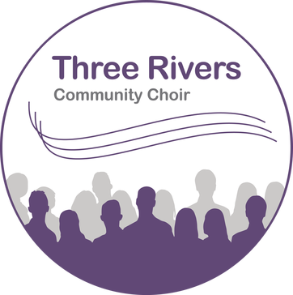

Directed by Ann Wright

and accompanied by Christine Evans

**Here’s to Song**

Ticket prices £6.00 (£4.00 students/under 16s)

Advance tickets on line at

<www.jumblebee.co.uk/threeriverscommunitychoirconcert>

or ask a member of the choir

For more information about the choir visit www.threeriverscommunitychoir.org.uk

The performance will include a new piece entitled ‘This, Our Day’ composed for the choir by Paul Smith, CEO of the VCM Foundation.

Three Rivers Community Choir present their Summer Concert at St Mary’s, Shaw-cum Donnington

Saturday 14th July

7.30pm (doors open 7pm)